LETTER 4 – under 89%

School headed paper

Full name of parent

Full address

Date

Dear

**Re: CHILD NAME AND ATTENDANCE PERCENTAGE**

**PERSISTENT ABSENTEE**

I write to inform you that despite the interventions outlined below a request for service has now be made to the Education Welfare Service who will consider any legal intervention.

***(insert attendance interventions/ offers of support)***

Failing to ensure regular attendance at school may result in the issuing of a Penalty Notice or prosecution. Penalty Notices are set at £60 if paid by 21 days and £120 if paid between 22 and 28 days. Any legal proceedings would relate to section 444 or 444(1A) of the Education Act 1996.

As a school we have a responsibility to continually monitor and review your child’s attendance. We are committed to working with you to improve your child’s attendance. If you wish to discuss this matter further, please contact me on {telephone number}.

Yours sincerely,

**Attendance Officer**

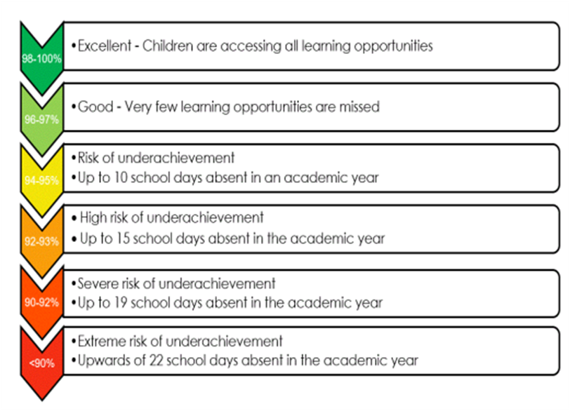

**Department for Education**

Working together to improve school attendance – Published May 2022/Applies from: September 2022