LETTER 3 – 90-92%

School headed paper

Full name of parent
Full address

Date

Dear

Re: CHILD NAME AND ATTENDANCE PERCENTAGE

I am concerned that despite previous interventions you have failed to provide a satisfactory explanation for (pupil’s name) absences. I enclose your child’s registration certificate for information.

EITHER (Delete whichever paragraph that does not apply)
You were recently invited to a meeting to discuss the attendance concerns but you failed to attend. The matter will now be escalated for discussion at a Targeted Support Panel, held jointly with an Officer from the Education Welfare Service. A decision will be made as to whether a referral to the service is appropriate at this stage.

OR You recently attended a meeting to discuss the continued absences. At that meeting we developed and agreed an attendance improvement plan together. A copy of this plan along with the meeting minutes are enclosed. Your child’s attendance has failed to improve and will now be discussed at a Targeted Support Panel, this will include an Officer from the Education Welfare Service.

Failing to ensure regular attendance at school may result in the issuing of a Penalty Notice or prosecution. Penalty Notices are set at £60 if paid by 21 days and £120 if paid between 22 and 28 days. Any legal proceedings would relate to section 444 or 444(1A) of the Education Act 1996.

We are committed to working with you to improve your child’s attendance. If you wish to discuss this matter further, please contact me on {telephone number}.
Yours sincerely

Attendance Officer

Enc. (select appropriate)
Attendance certificate
Attendance Improvement Plan
Meeting minutes

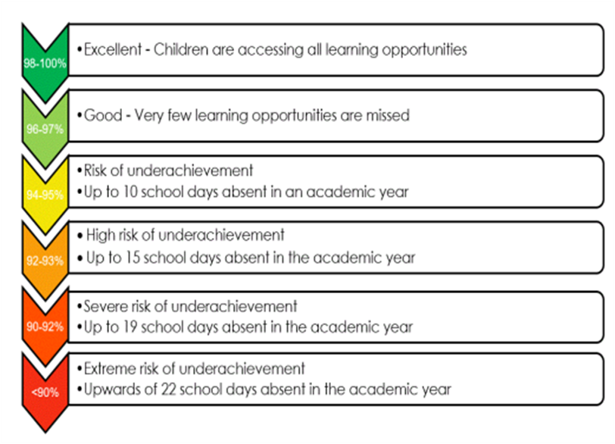

Department for Education
Working together to improve school attendance – Published May 2022/Applies from: September 2022

