paper

**PRIVATE AND CONFIDENTIAL**

Address

Date

Dear

**Re:**

Following our previous letter dated the 9th of October 2023 s attendance has failed to improve and now stands at . This means they have missed hours of learning so far this academic year

Studies confirm that poor attendance at school directly impacts on a pupil’s achievement. It is essential that she/he improves he/hisattendance in order to increase the chances of academic success.

In order to discuss this matter further I am inviting you to attend a meeting at school with me on:

At this meeting an attendance improvement plan will be developed in order to address any barriers your child may be experiencing and to look at strategies to support their attendance.

School will continue to monitor your child’s attendance. Should this fail to improve may be discussed at a Targeted Support Panel with the Local Authority.

We are committed to working with you to improve your child’s attendance. If you wish to discuss this matter further, please contact me on 0115 900 7210 ext 4233**`.**

Yours sincerely,

Miss Batchelor

**Attendance Officer**

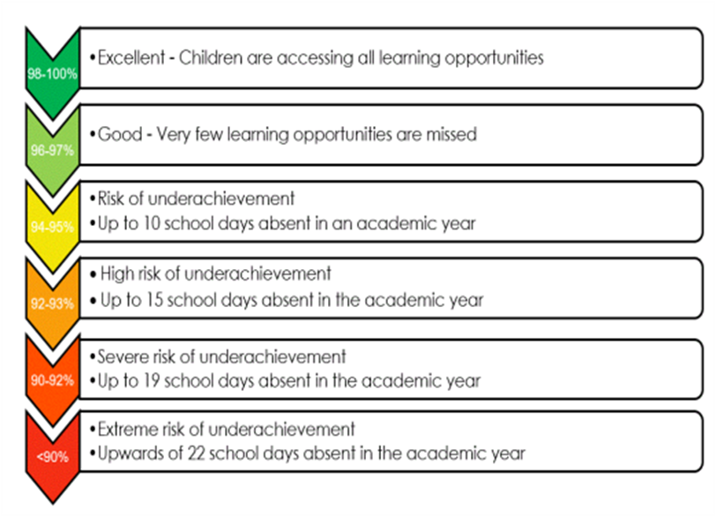

**Department for Education**

Working together to improve school attendance – Published May 2022/Applies from: September 2022