Title: Student Gmail / Google Classroom Access
Revision: v0.1
Author: M Binns

Contents
1. Version Control 2
2. Introduction 2
3. Accessing Gmail from Home 2
4. Accessing Google Classroom from Home 3

Version Control

Version Number | Author | Description of Changes Made
v0.1 | Michael Binns | Initial Draft

Introduction

This document has been written as a guide to cover the access of Gmail / Google Classroom when not on a trust device.

Accessing Gmail from Home

The simplest way to access Gmail from home is simply by using a slightly longer link than normal. In your web browser if you go to https://mail.google.com/a/bluecoat.uk.com the below login box will appear;
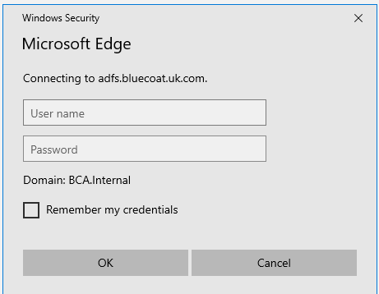

At this screen simply enter the normal username and password you use on the school computers this will then log you into Gmail ready for use as per the below;
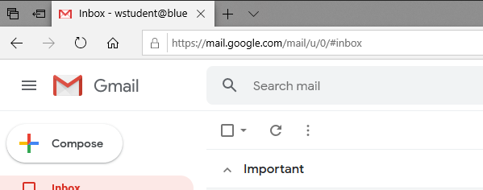

Accessing Google Classroom from Home

The simplest way to access Google Classroom from home is by using a slightly longer link than normal. In your web browser if you go to https://classroom.google.com/a/bluecoat.uk.com the below login box will appear;

At this screen simply enter the normal username and password you use on the school computers, this will then log you into Classroom ready for use as per the below;
